**GUJARAT TECHNOLOGICAL UNIVERSITY**

**COMPUTER ENGINEERING**

**“HELLO PROVIDER”**

**B.E.-7th -SEMESTER**

**CLASS-A**

**ACADEMIC YEAR:2019-2020**



GOVERENMENT ENGINEERING COLLEGE-MODASA

SUBMITTED BY:

160160107032-IYAVA DHARMESH V.

160160107062-PATEL SAGAR R.

160160107083-SABUWALA SHALIN G.

INTERNAL GUIDE:

Prof.V.V.NAYAK

**SOFTWARE REQUIREMENT SPECIFICATION (SRS)**

**FOR**

**HELLO PROVIDER**

Government Engineering College,Modasa



**DECLARATION**

We hereby declare that the **SRS** reports submitted with the **SRS** report for the project entitled ”**HELLO PROVIDER**” submitted to partial fulfilment for the **7th sem** of **bachelor of engineering** in **computer engineering** branch to Gujarat technological university, Ahmadabad, is a benefited record of the project work carried out at **GOVERNMENT ENGINEERING COLLEGE-MODASA** under the supervision of **Prof.V.V.NAYAK** and that no part of any these **SRS** reports has been directly copied from any student’s reports or taken from any other sources, without providing due reference.

**Name of student**

160160107032-IYAVA DHARMESH V.

160160107062-PATEL SAGAR R.

160160107083-SABUWALA SHALIN G.

Government engineering college,Modasa

CERTIFICATE

This to certify that the **SRS** reports, submitted along the project entitled “**HELLO PROVIDER**” has been carried out by **Dharmesh Iyava, Patel Sagar , Shalin Sabuwala** under my guidance in partial field for the degree of **bachelor of engineerin**g in **computer engineering** 7th semester of **Gujarat technological university, Ahmadabad** during the academic year 2019-20 these students have successfully completed SRS activity under my guidance.

**INTERNAL GUIDE**

Prof.V.V.NAYAK

**HELLO PROVIDER**

**DEFINITION**

“HELLO PROVIDER” is the software that can be use by the customer for solve their daily accessed accessories, which caters large number of people. This software basically known as service provider. a managed service provider is third party software that provides the basic services to the customer.

The system should get the user details such as name, age, address, mobile no which the system can provide the basic services to the user.

The software should provide search options. the option is like ac repairing, refrigerator repairing and more often services that the user can access his/her needed services through this software.

The software should have option for checking availability of the service man. If the service men is not available for the user location, a short message will appear as “service unavailable” will be displayed to the user. The software should have facility to cancel the booking of the service and also can modify the changes if the customer has some changes in his booking service.

A small statement regarding cancellation should be displayed to user after cancellation of their services. The service which is cancelled is then added up to the available column. The software should have the facility to print the booked services with all the details such as data, name of the service man, his phone no with timings and the service name along with the customer details.

The price list of the service is also put up according to the the services that would be choose by the customer.

**HELLO PROVIDER**

**SOFTWARE REQUIREMENTS SPECIFICATION**

1. **INTRODUCTION**

**1.1PURPOSE**

The main purpose of this software is to provide the basic services to the customer. that software provide flexible work on time and customer requirement.

**1.2 SCOPE**

The name of the software is “HELLO PROVIDER”. This provides options for viewing different services available with different  timings  for  a particular date and provides customers with thefacility to book a service, modify or cancel a particular booking and it does provide the customers with details of cost of the service and it does not allow the customer to modify a particular part of his booking and he/she can modify all his details.

**1.3 ACRONYMS AND ABBREVIATIONSARS**

LAN-Local Area Network GUI-Graphical User Interface OS-Operating System RAM-Random Access Memory MB-Mega Bytes GB-Giga Bytes Mbps-Mega bits per second HDD-Hard Disk Drive.

**1.4 REFERENCES**

The books and materials referred during the pre-development stages of the project . And the advance reference of this project is “urban clap” website and application.

**1.5 OVERVIEW**

The rest of the document deals about all the main features of this software each will its purpose and its main functions. It also gives details about the interface with other products and related functionality of each product.

**2. OVERALL DESCRIPTION**

**2.1 PRODUCT PERSPECTIVE**

The “HELLO PROVIDER” software is an independent website self contained product. The system interfaces, user interfaces and hardware interfaces related with this software are defined as follows.

**2.1.1 System Interfaces**

The client systems should be able to share the data available in the data base through the network connection.

.

**2.1.2 User Interfaces**

The screen formats and menu structure should be in such a way that even have users will find it easy to use. The product must be use-friendly and very inter-active. The functionality provided by the system like displaying error messages should adapt itself to the different users of the software.

**2.1.3 Communication Interfaces**

There is an LAN used for communication among the different client systems to be used.

**2.1.4 Memory Constraints**

The system would require disk space of 10 GB and a 256 MB HDD and 64MB RAM for client systems.

**2.1.5 Operation**

The users can first make a booking in a particular service for a particular date and time. The system provides the customer with a code which gives him access to either make any changes in his booking or cancel a booking. These must also be back up of data to enable any easy recovery from any features.

**2.1.6 Site Adaptive Requirements**

The “HELLO PROVIDER” software is an independent and self-contained product and no modification are required to adapt to a particular installation.

**2.2 PRODUCT FUNCTIONS**

The major functions include

* Providing service details
* service bookings for a particular destination, date and time and also providing with a code.
* Allowing the customer to modify or cancel his booking provided the correct pin code of his/her location.
* Displaying a report of the number of service men.
* Work done in flexible time.
* Professional behaviour by the service man.

**2.3 USER CHARACTERISTICS**

  No technical experience is required basic knowledge of handling system is sufficient.

**2.4 CONSTRAINTS**

•Regulatory policies: It is a mandatory that no text book must be left empty or contains insufficient data.

•Hardware limitations: There must be a 64 MB on board memory

•Control functions: The software must be very user-friendly and display appropriate error messages.

•Interfaces to other applications: Not applicable.

•Parallel operations: It must support many users simultaneously.

•Reliability requirements: Data redundancy and use of special/blank characters must be avoided.

•Safety/security considerations: The application must be exited always normally.

•Higher order language requirements: java

**2.5 ASSUMPTIONS AND DEPENDENCIES**

It is assumed that the details of the cost of services are already known to the customer. Future changes like providing different types of services with different service man ,will allow the customers to complain through the software.

**3. SPECIFIC REQUIREMENTS**

**3.1 EXTERNAL INTERFACE REQUIREMENTS**

**3.1.1 User Interfaces**

The interface must be easy to understand. The user interface includes

•SCREEN FORMATS/ORGANIZATION:

 The introductory screen will be the first to be displayed which will allow the users to choose either of the two options, viewing service detail or booking a service.

•WINDOW FORMAT/ORGANIZATION:

 When the user chooses some other option, then the information pertaining to that choice will be displayed in a new window which ensures multiple windows to be visible on the screen and the users can switch between them.

**3.1.2 Hardware Interfaces**

The system must basically support certain input and output devices. There are as bellow:

|  |  |  |
| --- | --- | --- |
| **Name Of Item** | **Description of Purpose** | **Source of Input/**  **Description of output** |
| **Key Board** | To accept data from user like pin code, name, age, location etc. | Source of input |
| **Printer** | To print bookings mode E.g: services chosen with date and timing. | Destination of Output |

**3.1.3 Software Interfaces**

 Not applicable since the product under considerations is an independent one.

**3.1.4 Communication Interfaces**

Every client system connected through LAN establishes a communication only with the server and not with any client system. An LAN of 10 Mbps is used.

**3.2 PERFORMANCE REQUIREMENTS**

•At any instant, a maximum of four nodes or users will be given access simultaneously.

•Since the program handles multiple users, if more than one person attempts to same date to the files stored in the data base, the program will lock the data file using a 2-phase commit protocol to prevent simultaneous access.

**3.3 DESIGN CONSTRAINTS**

•Requires 256 MB on-board memory.

•Based completely on Windows functionality platform.

**3.4 SOFTWARE SYSTEM ATTRIBUTES**

**3.4.1 Reliability**

The factors needed to establish the software expected reliability are

The user inputs should be valid and within the given range.Normal termination of the program.

**3.4.2 Availability**

The factors guarantee the software’s availability includes proper terminationand correct input details. Also the resources used for the projectdevelopment are Microsoft Certified which speaks of its high quality standards.

**3.4.3 Security**

•It must be ensured that access will be provided to the authorized persons through user ID and password.

•Network security will be provided by the use of firewalls.

•Checks can be performed at regular internals to ensure data integrity.

**3.4.4 Maintainability**

The software will be developed by implementing the concept of modularity which in turn reduces the complexity involved in maintaining it. Theadministrator should have a sound technical knowledge about maintaining the software and further enhancements will be undertaken by the developer.

**3.4.5 Portability**

The application is portable which ensures its adaptability for use on different computer terminals with different operating systems and standards.

**3.5 LOGICAL DATABASE REQUIREMENTS**

The system requires the use of text files to maintain the customers personal details and his booking details. An entity must be used to specify the various departments and the seats available in them. This information will be used frequently by the authorities for verification

**4.MODELING**

**4.1 E-R DIAGRAM**

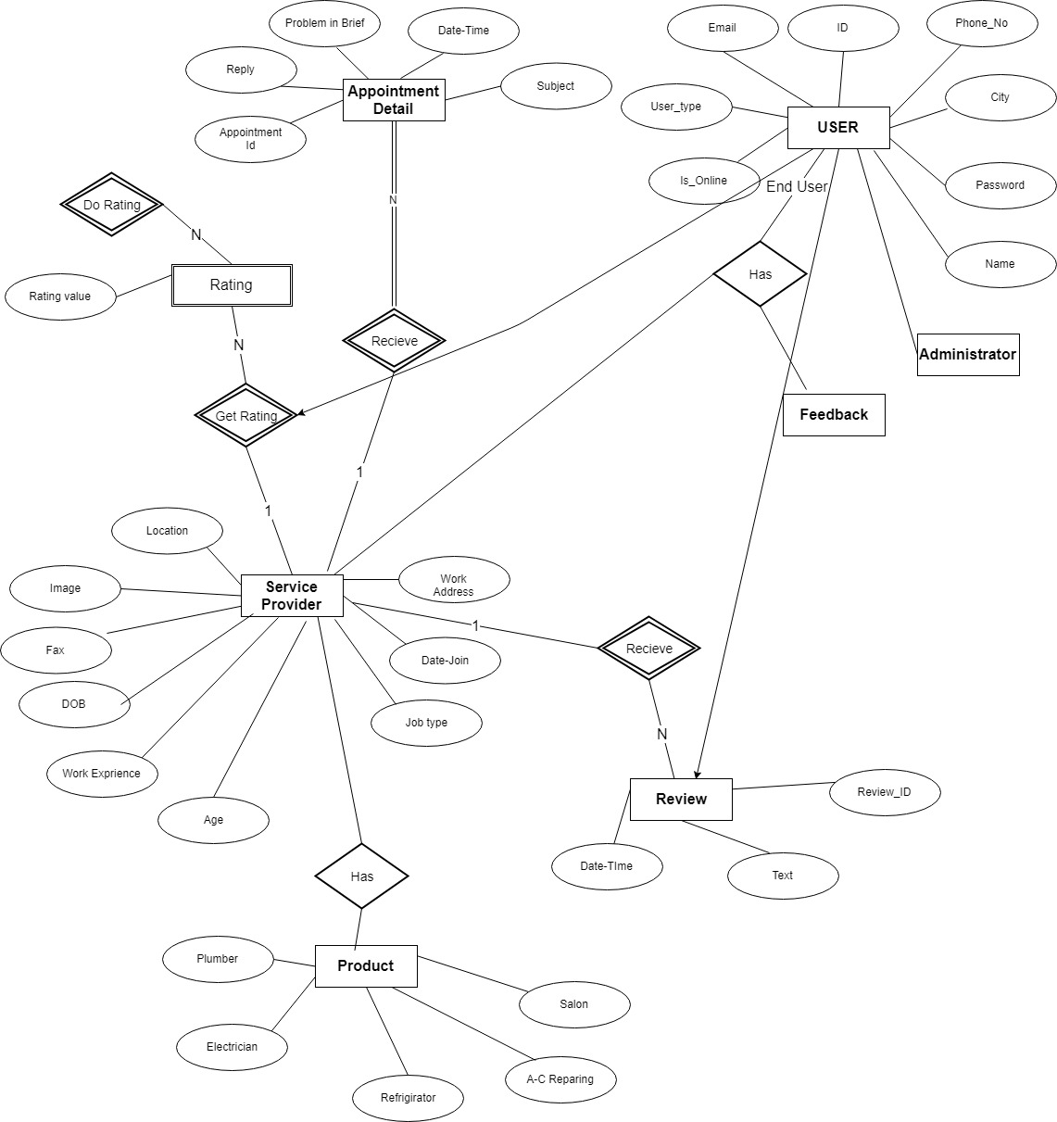

**4.2 CLASS DIAGRAM**

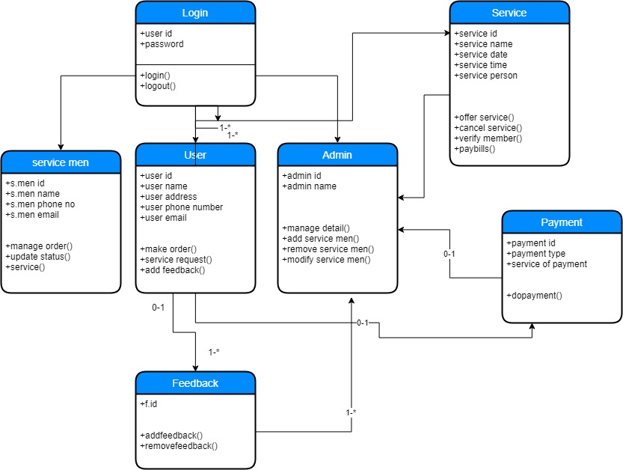

**4.3 DATA FLOW DIAGRAM**

**LEVEL:0**

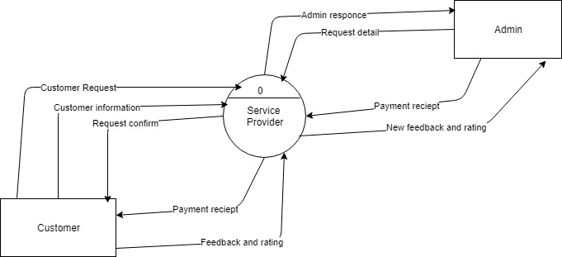

**Level:1**

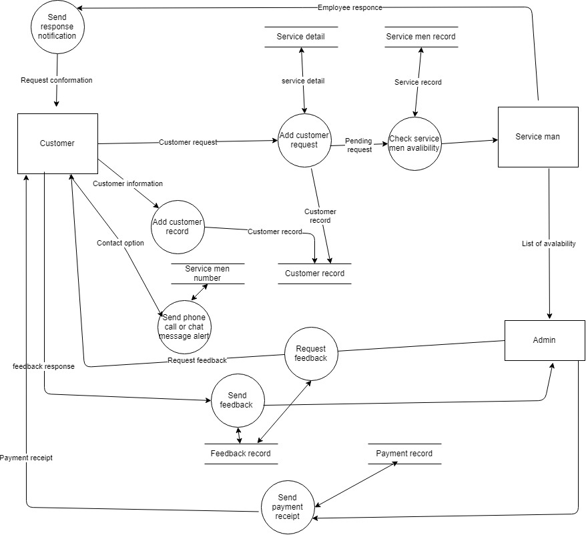

**Level:2**

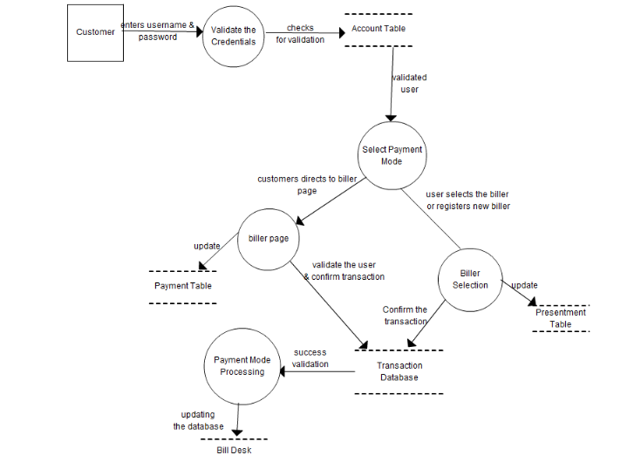

**4.4 SEQUENCE DIAGRAM**

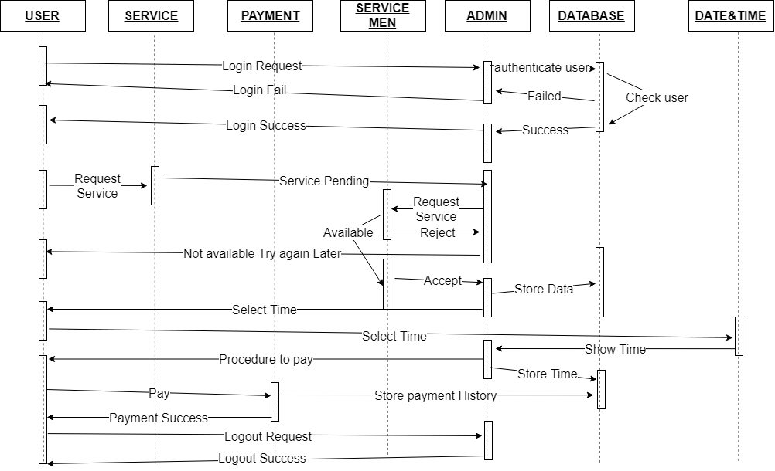

**4.5 USE CASE DIAGRAM**

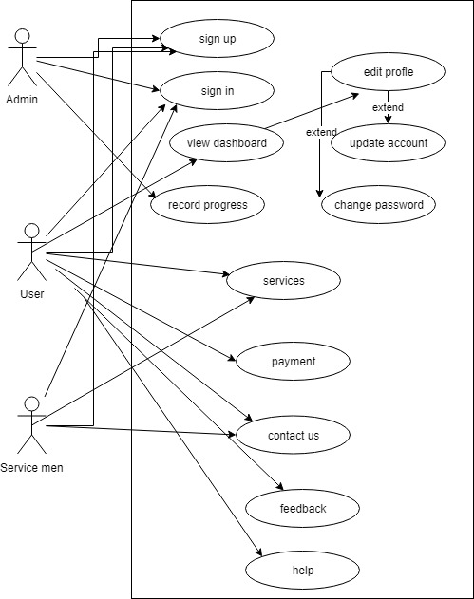

**5.DATABASE**

**5.1 Customer’s Table**

|  |  |  |  |
| --- | --- | --- | --- |
| **Attribute** | **Data Type** | **Description** | **Size** |
| First_Name | Varchar2 | First name of customer | 50 |
| Last_Name | Varchar2 | Last name of customer | 50 |
| Email | Varchar2 | Email of customer | 30 |
| Password | Varchar2 | Create password | 10 |
| location | Varchar2 | Customer’s location | 20 |

**5.2 service’s Table**

|  |  |  |  |
| --- | --- | --- | --- |
| **Attribute** | **Data Type** | **Description** | **Size** |
| Name of services | Varchar2 | Services name | 30 |
| Service id | Varchar2 | Customer password | 30 |
| Price of service | number | Price of service | 10 |

**5.3 service man’s Table**

|  |  |  |  |
| --- | --- | --- | --- |
| **Attribute** | **Data Type** | **Description** | **Size** |
| Service man name | Varchar2 | Name of service man | 20 |
| Service man mobile no | Varchar2 | Mobile no of service man | 20 |
| Service man id number | number | Id number of service man | 20 |

**5.4 booking Table**

|  |  |  |  |
| --- | --- | --- | --- |
| **Attribute** | **Data Type** | **Description** | **Size** |
| Service  name | Varchar2 | Name of service | 20 |
| Service  id | Number | Id of service | 20 |
| price | Number | Cost of service | 10 |
| Date of  service | Date | Date of service | 10 |

**6. HARDWARE AND SOFTWARE REQUIREMENT**

**6.1 HARDWARE REQUIREMENT**

The server should be equipped with a processor speed of over 1.5 GHz and a memory of over 512 MB. The required software for “HELLO PROVIDE” software System project would be as follows: Operating System, Microsoft Windows Professional.

**6.2 SOFTWARE REQUIREMENT**

The system requires the use of text files to maintain the customers personal details and his booking details. An entity must be used to specify the various departments and the service available in them. This information will be used frequently by the authorities for verification.